**212241803537 赵启程**

一、程序源码

module Detector_10010 (clk,reset,x,z);

input clk,reset;

input x;

output z;

reg z;

reg [4:0] current_state,next_state;

// 参数声明

parameter [4:0] IDLE = 5'b00000,

A = 5'b00001,

B = 5'b00010,

C = 5'b00100,

D = 5'b01000,

E = 5'b10000;

/*-----------------------------------------------------

@file 状态寄存

@brief 时序逻辑电路

@details posedge clk or posedge reset

-----------------------------------------------------*/

always @(posedge clk or posedge reset)

begin

if (reset)

begin

current_state = IDLE;

end

else

begin

current_state = next_state;

end

end

/*-----------------------------------------------------

@file next_state

@brief 组合逻辑电路

@details current_state or x

-----------------------------------------------------*/

always @(current_state or x)

begin

case (current_state)

IDLE:

begin

if (x == 1)

begin

next_state = A;

end

else

begin

next_state = IDLE;

end

end

A:

begin

if (x == 0)

begin

next_state = B;

end

else

begin

next_state = A;

end

end

B:

begin

if (x == 0)

begin

next_state = C;

end

else

begin

next_state = A;

end

end

C:

begin

if (x == 1)

begin

next_state = D;

end

else

begin

next_state = IDLE;

end

end

D:

begin

if (x == 0)

begin

next_state = E;

end

else

begin

next_state = A;

end

end

E:

begin

if (x == 1)

begin

next_state = A;

end

else

begin

next_state = C;

end

end

default:

begin

next_state = IDLE;

end

endcase

end

// 第三段always

// always @(posedge clk or posedge reset)

/*always @(current_state or x)

begin

if (reset)

begin

z = 1'b0;

end

else

begin

case (current_state)

IDLE:z = 0;

A:z = 0;

B:z = 0;

C:z = 0;

D:z = 0;

E:z = 1;

default:z = 0;

endcase

end

end*/

/*-----------------------------------------------------

@file 输出

@brief 组合逻辑电路

@details current_state or x

-----------------------------------------------------*/

always @(current_state or x)

begin

case (current_state)

IDLE:z = 0;

A:z = 0;

B:z = 0;

C:z = 0;

D:z = 0;

E:z = 1;

default:z = 0;

endcase

end

endmodule

二、状态转移图

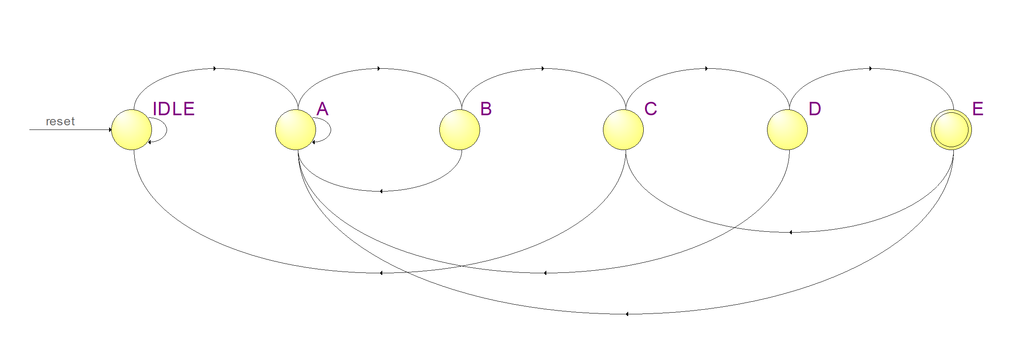

三、仿真波形